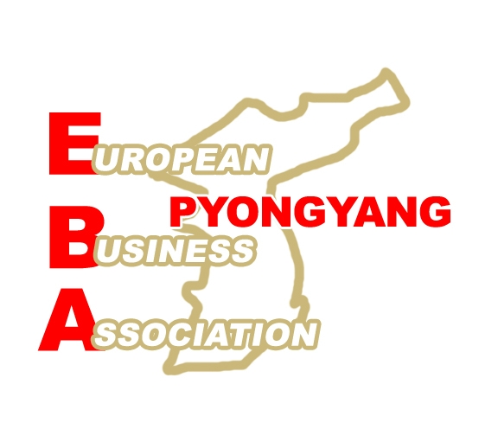 | President: Mr Felix Abt  Person in Charge of Trade Fairs: Dr. Barbara Unterbeck  Address:  Embassy Village Munsudong, Bulgarian Compound  Pyongyang, DPR Korea  Tel. 00850-2-381 7344, Fax 00850-2-381 7355  barbara.unterbeck@kcckp.net

Registration Form for the EBA Booth at the

4^{h} Pyongyang Autumn International Trade Fair 22 - 25 September 2008

Name of the company:
Contact Person:

Position in company:

Address of the company:

Tel.:

Fax:

e-mail:

website:

Business Fields:
Interested in:

POSTER: We will send a corporate poster in digital form in English, EBA will probably translate some Korean key sentences to be confirmed by us. Printing will be done in Pyongyang.

FLYERS, LEAFLETS etc / SAMPLES: We will send our material by DHL.

We are informed that posters and leaflets must not carry a contact address from the US, Japan, or the Republic of Korea.

We transfer the participation fee to the bank account to be informed. EBA will give the details for remittance after receiving this registration form.

We accept that the EBA committee reserves the right to reject a registration without giving reasons and will, in such a case, return the participation fee.

Date: | Stamp and Signature:

